BIRLA INSTITUTE OF TECHNOLOGY & SCIENCE, PILANI
Work Integrated Learning Programmes Division
Second Semester 2024-2025
Comprehensive examination
(EC-3 Regular)
Course No. : AIMLCZC418
Course Title : Introduction to Statistical Methods
Nature of Exam : Open Book
No. of Pages = 3
No. of Questions = 5
Weightage : 40%
Duration : 2 Hours
Date of Exam : 06-09-2025_FN
Note to Students:
- Please follow all the Instructions to Candidates given on the cover page of the answer book.
- All parts of a question should be answered consecutively. Each answer should start from a fresh page.
- Assumptions made if any, should be stated clearly at the beginning of your answer.

1.a) The following sample data shows the scores (out of 20) of 5 students in two subjects, Mathematics (X) and Statistics (Y). Calculate Karl Pearson’s coefficient of correlation and interpret your result. [4 Marks]
Student | Mathematics(X) | Statistics(Y)
Ram | 12 | 15
Sham | 8 | 10
Rupa | 16 | 18
Anil | 6 | 9
Sunil | 14 | 16

b) A pharmaceutical company claims that their new drug reduces blood pressure by an average of 15 mmHg. A sample of 25 patients shows an average reduction of 13 mmHg with a standard deviation of 5 mmHg. Test the claim at 5% significance level. [4 marks]

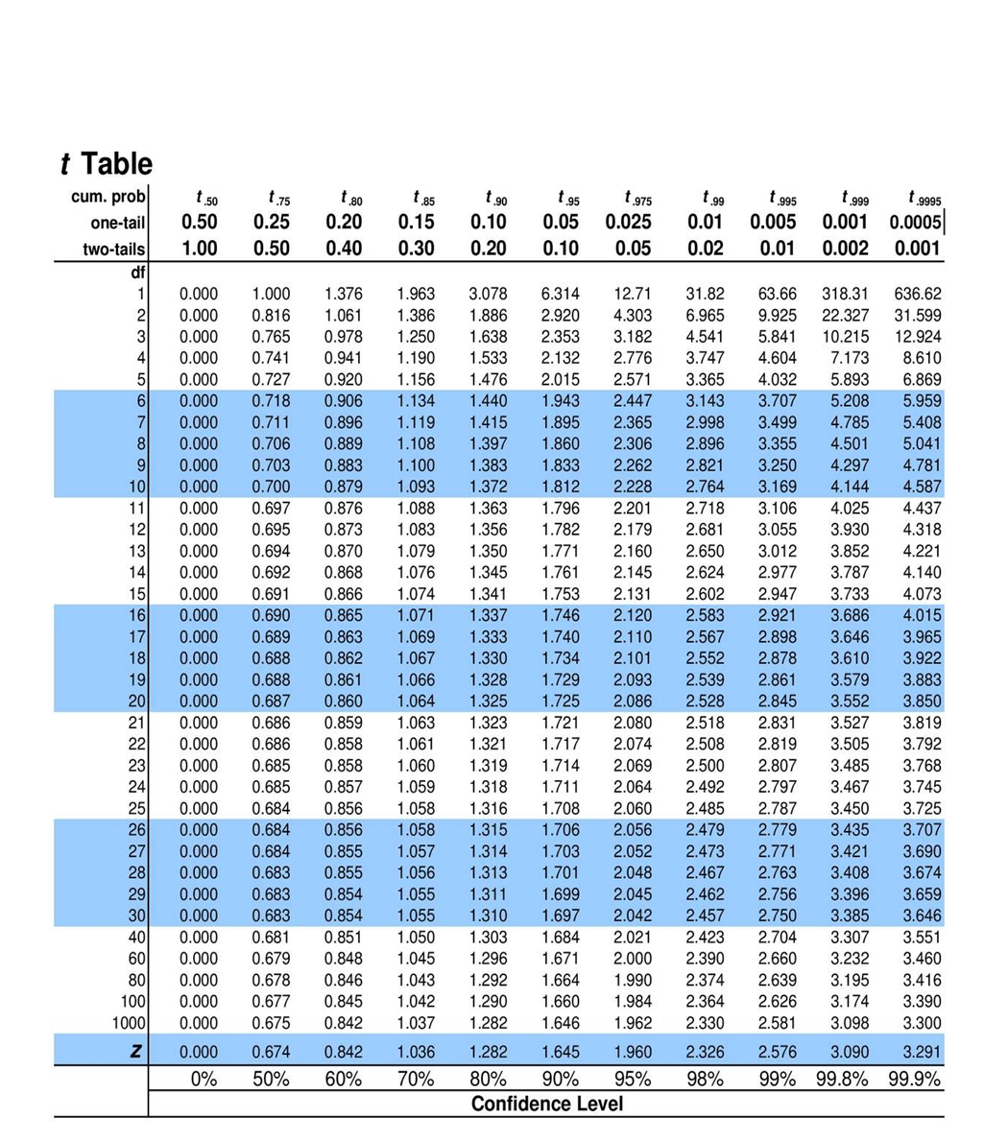
2. The following data relates to the export of rice (in thousands of quintals) to USA from 2015
to 2021 [8 Marks]
Year | 2015 | 2016 | 2017 | 2018 | 2019 | 2020 | 2021
Export | 146 | 159 | 161 | 170 | 174 | 140 | 145

Using the Simple Exponential Smoothing technique, answer the following:
- Forecast the export for the year 2022 using α = 0.3, assuming the initial forecast for 2015 is equal to the actual export value in that year.
- Forecast the export for the year 2022 using α = 0.6, with the same initial condition as in part (i).
- Determine which of the two smoothing constants (α = 0.3 or α = 0.6) provides a better forecast based on Mean Squared Error (MSE) and justify your answer.

- A Chemical company, wishing to study the effect of extraction time on the efficiency of an extraction operation, obtained the data as shown in the following table: [8 Marks]
Extraction time (minutes) X | 27 | 45 | 41 | 19 | 35 | 39 | 19 | 49 | 15 | 31
Extraction  Efficiency (%) Y | 57 | 64 | 80 | 46 | 62 | 72 | 52 | 77 | 57 | 68
- Fit a Straight line to the given data by the method of least squares.
- Use it to predict the extraction efficiency when the extraction time is 35 minutes.
- Draw a scatter plot for the given data.

- A start-up offers a streaming service and is experiencing steady growth in monthly paid subscriptions. The last six months’ data is: [8 Marks]
Month | Subscriptions (in thousands)
Jan | 15
Feb | 18
Mar | 22
Apr | 25
May | 29
Jun | 33

The company wants to forecast July subscriptions using Holt’s method. Parameters are:
α = 0.5, β = 0.3, Initial level L₀ = 15, Initial trend T₀ = 3
- Apply Holt’s smoothing step-by-step to forecast for July.
b) Briefly explain why trend smoothing (β) is critical for subscription growth forecasting.
5a) A manufacturing company produces precision shafts used in high-speed machinery. Two
different machining methods (Method A and Method B) are used to achieve the required
diameter tolerance. Both methods produce shafts with the same average diameter, but the
quality control engineer wants to determine which method has less variability in diameter.
A random sample of 10 shafts from Method A yields a sample standard deviation of 0.032
mm, while a random sample of 14 shafts from Method B gives a sample standard deviation
of 0.028 mm. At the 5% level of significance, is there sufficient evidence to conclude that
Method A has greater variability than Method B? [4 Marks]

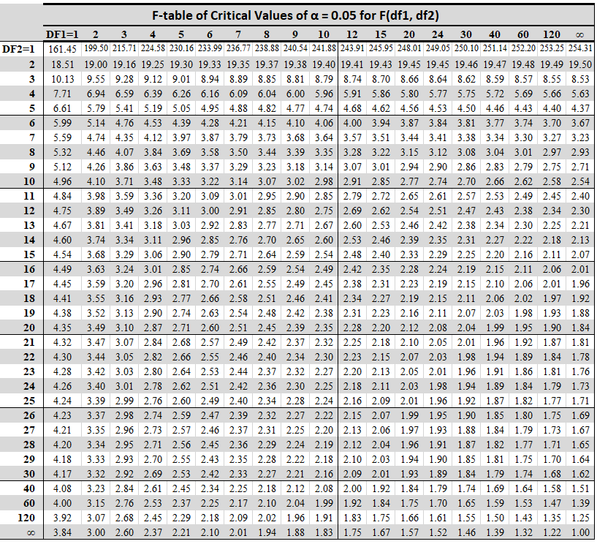

- In a particular city, the number of car accidents per day follows Poisson distribution. On five randomly chosen days, the number of accidents recorded was 4, 2, 5, 3, and 6.
[4 Marks]

- Find the maximum likelihood estimate (MLE) of the average number of accidents per day.
- Using the MLE from (i), estimate the probability that there will be no accidents on a randomly chosen day.
***************

